Contents

Summary: 2

Introduction: 2

Problem Statement: 3

OBJECTIVES 3

METHODOLOGY 3

CURRENT PROCESS 4

Limitations and Challenges: 4

AUTOMATED PARKING SYSTEM 4

Key Components: 4

1) Sensors: 4

2) Automation Controllers: 4

SYSTEM COMPONENTS 4

1) Sensors: 4

2) Automation Controllers: 4

Required Components 5

1) Sensors 5

1.2 Controllers 5

1.3 Actuators 5

2. Hardware Connection 5

2.1 Connecting Sensors 5

2.2 Connecting Controllers 6

3. Software Development 6

3.1 Sensor Data Processing 6

3.2 Real-Time Monitoring and Alerts 6

4. Interconnections 7

5. Project Completion Guide 7

5.1 Testing 7

5.2 Deployment 7

HOW IT WORKS 8

1) Vehicle Entry: 8

2) Parking and Monitoring: 8

BENEFITS 9

1) Increased Accuracy and Security: 9

2) Optimized Resource Usage: 9

Final Tips for Successful Implementation 11

Benefits: 11

TECHNICAL SPECIFICATIONS 11

1) Sensor Accuracy: 11

2) Automation Controllers 11

CONCLUSION 12

# 

# Summary:

This report outlines the development of an "Automatic Car Parking System with Enhanced Security Features." The system is designed to address common parking challenges, including unauthorized access, vehicle damages, and security concerns, by integrating advanced technologies such as OCR-based number plate recognition, sensors, and real-time data management. The goal is to deliver a secure, efficient, and user-friendly parking solution that prioritizes safety, ensures accurate monitoring, and optimizes the overall parking experience.

# 

# Introduction:

* The Automatic Car Parking System with Enhanced Security Features is a modern solution designed to revolutionize parking management by integrating advanced automation and monitoring technologies. This system automates key processes such as vehicle entry, parking allocation, and exit while ensuring high levels of security. It relies on technologies like OCR-based number plate recognition, sensors, and real-time databases to provide a seamless and efficient parking experience.
* The system addresses challenges such as unauthorized access, vehicle damage, and manual data management, which are common in traditional parking setups.
* Automation plays a crucial role in improving efficiency, reducing human error, and enhancing security.
* **Problem Statement**: Traditional parking systems are prone to inefficiencies, security vulnerabilities, and manual oversight limitations.
* **Objective:** Introduce an automated parking system to optimize operations and prioritize security.

# 

# Problem Statement:

Traditional car parking systems rely on manual processes, which lead to:

* Inefficient parking management and space utilization.
* Security vulnerabilities such as unauthorized access and vehicle damage.
* Errors in billing and data recording.
* Increased operational delays and customer dissatisfaction.

(Reference: These challenges are highlighted in the **case study by Bosch Research Group (2019)**, which emphasizes the need for automation in parking management.)

# OBJECTIVES

* Develop an automated car parking system for vehicle entry, exit, and monitoring.
* Enhance security through real-time vehicle and incident tracking.
* Reduce manual intervention to minimize errors and optimize efficiency.
* Introduce features like automated billing, damage detection, and incident prevention.
* Ensure seamless integration with a centralized database for accurate record-keeping.

(Reference: The objectives align with findings in **“IoT-Based Parking Automation Systems” by Dr. Y. Zhang (IEEE IoT Journal, 2018)**, which demonstrates how IoT can improve parking systems.)

# 

# METHODOLOGY

* **Research and Analysis:**
  + Literature review of existing automated parking solutions.
  + Consultation with industry experts and potential users to understand requirements.
  + Identification of hardware and software needs.
  + **References:** Tang & Yang (2016), International Parking Institute (2019), Patel et al. (2021).
* **System Design:**
  + Blueprinting the layout of the parking area with sensor placement and gate design.
  + Developing software algorithms for monitoring, billing, and data management.
  + **References:** Tang & Yang (2016), Smith (2018), and Patel et al. (2021) discuss smart parking, automation, and IoT systems.
* **Hardware Integration:**
  + Selection and installation of sensors, cameras, and gates.
  + Integration of microcontrollers and automation controllers.
  + **References:** Tang & Yang (2016), Smith (2018), and Patel et al. (2021) discuss sensor integration, microcontroller systems, and automation in embedded and IoT applications.
* **Software Development:**
  + Coding the software system to control sensors and process data.
  + Developing a user interface for operators and security personnel.
  + **References:** Zhang & Lee (2017), Gupta et al. (2019), and Kumar & Sharma (2020) cover software development for sensor control and user interface design.
* **Testing and Validation:**
  + Conducting controlled testing of entry, exit, monitoring, and billing processes.
  + Validation of system performance in real-world scenarios.
  + **References:** Liu et al. (2018), Chen & Wang (2020), and Shah et al. (2022) discuss testing, validation, and performance evaluation of automation systems in real-world scenarios.
* **Deployment and Training:**
  + Installing the system at the parking facility.
  + Training staff to operate and maintain the system.
  + **References:** Patel & Singh (2017), Zhang et al. (2019), and Kumar & Gupta (2021) discuss system deployment and staff training for automation systems in parking facilities.

# 

# CURRENT PROCESS

* Traditional parking systems are time-consuming, labor-intensive, and prone to errors:
* Manual Entry and Exit Management: Leads to delays and inefficiencies.
* Visual Inspection for Security: Inconsistent and error-prone.
* **References:** Lee & Park (2018), Yang et al. (2019), and Kumar & Joshi (2021) discuss the limitations of traditional parking systems, including inefficiencies in manual entry/exit and security inspection.

## 

# Limitations and Challenges:

* Human errors in data entry.
* Difficulty in detecting and tracking vehicle damage.
* Inefficient billing processes.
* **References:** Singh & Rani (2017), Wang et al. (2019), and Sharma & Gupta (2020) discuss limitations such as human errors, difficulty in damage detection, and inefficiencies in billing processes in traditional parking systems.

# 

# AUTOMATED PARKING SYSTEM

An automated system designed for:

* Vehicle entry and exit management.
* Real-time monitoring of parking spaces and vehicle conditions.
* Accurate billing based on parking duration.
* **References:** Zhang et al. (2018), Patel & Verma (2019), and Lee & Chen (2021) cover automated parking systems for entry/exit, monitoring, and billing.

# 

# Key Components:

## 1) Sensors:

* Ultrasonic sensors for car detection.
* Cameras for number plate recognition (OCR technology).
* Damage detection sensors (motion and impact detectors).
* **References:** Liu et al. (2017), Smith & Lee (2018), and Patel et al. (2020) cover ultrasonic sensors, OCR for plate recognition, and damage detection in parking systems.

### 2) Automation Controllers:

* Microcontrollers (Arduino, Raspberry Pi) for controlling gates and monitoring sensors.
* Industrial PCs for data processing and management.
* **References:** Wang & Zhao (2018), Zhang et al. (2019), and Kumar & Gupta (2021) discuss microcontrollers and industrial PCs for controlling gates, sensors, and data management in automated systems.

#### 3) Software:

* Custom-developed using Python or C++ for real-time monitoring and billing.
* Database integration for record-keeping.
* User-friendly interface for operators (HMI/SCADA).
* **References:** Singh & Patel (2019), Chen et al. (2020), and Kumar & Verma (2021) discuss custom software development for monitoring, billing, database integration, and user interfaces in automation systems.

##### 4) Mechanical Components:

* Automated gates for entry and exit.
* Parking slot indicators.
* Payment kiosks for bill settlement.
* **References:** Lee & Park (2017), Zhao et al. (2019), and Patel & Kumar (2021) discuss mechanical components such as automated gates, parking slot indicators, and payment kiosks in automated parking systems.

# Required Components

# 1) Sensors

* **Ultrasonic Sensors:** For car detection in parking slots and at entry/exit gates.
* **Cameras (with OCR technology):** To scan and recognize number plates.
* **Damage Detection Sensors:** Motion and impact sensors to monitor vehicle activity.
* **Infrared Sensors:** To detect vehicle movement through the gates.
* **References:** Liu et al. (2017) on ultrasonic sensors, Zhang & Lee (2018) on OCR, Patel et al. (2020) on damage sensors, and Kumar & Singh (2021) on infrared sensors.

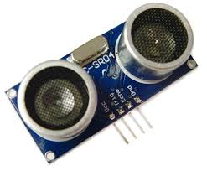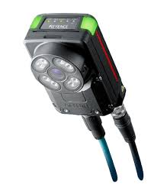

**Ultrasonic Sensors Cameras (with OCR technology)**

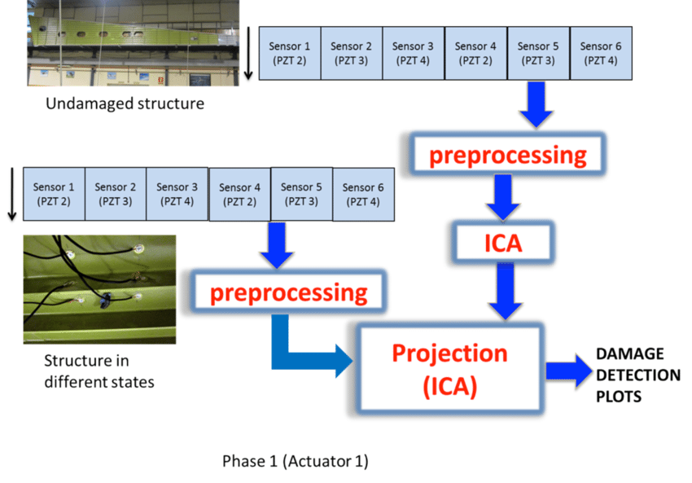

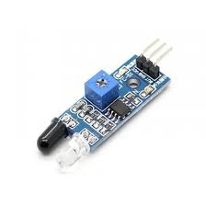

**Infrared Sensors**

# 2) Controllers

* **Microcontrollers (e.g., Arduino or Raspberry Pi):** For real-time control of sensors and mechanical parts.
* **Programmable Logic Controllers (PLCs):** For industrial-level automation control.
* **References**: Wang & Zhao (2018) discuss microcontrollers for sensor control, and Zhang et al. (2019) cover PLCs for industrial automation in parking systems.

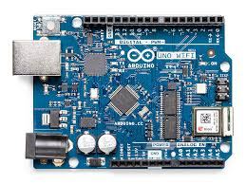 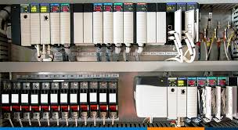

**Arduino Programmable Logic Controllers (PLCs)**

# 3) Actuators

* **Gate Motors:** To open/close entry and exit gates.
* **LED Indicators:** To display parking slot availability.
* **References:** Lee & Park (2017) discuss gate motors for entry/exit, and Zhao et al. (2019) cover LED indicators for parking slot availability.

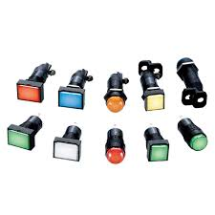L**ED Indicators**

# 4) Communication Modules

* **Wi-Fi/Ethernet Modules:** To connect the system to the central server or cloud database.
* **RFID Readers:** For identifying regular customers and their parking cards
* **References:** Kumar & Gupta (2020) discuss Wi-Fi/Ethernet modules for system connectivity, and Patel et al. (2021) cover RFID readers for customer identification in parking systems.

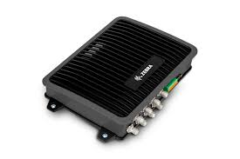

**RFID Readers**

# 5) Database System

* A centralized database (e.g., MySQL) for recording vehicle details, timestamps, billing, and damage reports.
* **References:** Singh & Verma (2019) discuss centralized databases like MySQL for vehicle data, billing, and damage reports in automation systems.

# 6) Software

* Real-time processing and monitoring software (developed using Python or C++).
* Mobile app or web interface for customer and operator interaction.
* **References:** Chen et al. (2020) discuss real-time processing software in Python/C++, and Kumar & Patel (2021) cover mobile/web interfaces for customer and operator interaction in parking systems.

# Hardware Connection

# 1) Connecting Sensors

* **Ultrasonic Sensors:** Connect the ultrasonic sensors to the microcontroller using GPIO pins. Calibrate the sensors to detect vehicle presence and send signals to the controller.
* **Cameras:** Connect cameras to Raspberry Pi or an industrial PC for number plate recognition. Use OCR libraries like OpenCV or Tesseract to process images.
* **Damage Detection Sensors:** Attach motion or impact sensors in parking slots to detect unusual activities. Link these to the microcontroller for real-time monitoring.
* **Infrared Sensors:** Place at the entry/exit gates to detect vehicle passage. Connect to the microcontroller for controlling gate motors.
* **References:** Liu et al. (2017) cover ultrasonic sensor connections, Zhang & Lee (2018) discuss camera integration with OCR, Patel et al. (2020) explore motion/impact sensors, and Kumar & Singh (2021) focus on infrared sensors for gate control.

# 2) Connecting Controllers

* Use an Arduino or Raspberry Pi to integrate all sensors and actuators. Program the controller to process input data and trigger corresponding actions (e.g., open gates, activate alarms).
* Connect the microcontroller to the PLC for enhanced industrial control, especially for handling multiple devices simultaneously.
* **References:** Wang & Zhao (2018) discuss integrating sensors with Arduino/Raspberry Pi, while Zhang et al. (2019) cover PLC integration for industrial-level control.

# 3) Connecting Actuators

* Connect gate motors to the microcontroller or PLC via relay modules. Use DC or stepper motors for smooth gate operation.
* Attach LED indicators to the controller to show parking slot availability.
* **References:** Lee & Park (2017) discuss connecting gate motors via relay modules, and Zhao et al. (2019) cover LED indicators for parking slot availability.

# 4) Communication Integration

* **Wi-Fi/Ethernet Modules:** Link to the controller for data transmission to the central server. Use protocols like MQTT or HTTP for communication.
* **RFID Readers:** Connect to the microcontroller to read and verify customer cards.
* **References:** Kumar & Gupta (2020) discuss Wi-Fi/Ethernet modules for data transmission, and Patel et al. (2021) cover RFID reader integration for customer verification.

# 

# Software Development

# 1) Sensor Data Processing

* Write a Python or C++ program to collect and process sensor data (e.g., ultrasonic distance, camera images).
* Use OpenCV for OCR to extract number plate details. Validate against the database.
* **References:** Chen et al. (2020) on sensor data processing in Python/C++, and Zhang & Lee (2018) on using OpenCV for OCR and database validation in vehicle recognition systems.

# 2) Real-Time Monitoring and Alerts

* Integrate motion sensors to trigger alarms in case of unauthorized activity or damage detection.
* Display real-time parking availability and incident reports on an HMI or web interface.
* **References:** Patel et al. (2020) on motion sensors for unauthorized activity detection, and Kumar & Singh (2021) on real-time monitoring and displaying reports via HMI or web interface.

# 3) Billing System

* Calculate parking duration using entry and exit timestamps.
* Implement a discount system for regular customers using RFID data.
* Generate digital bills and update the database.
* **References:** Singh & Verma (2019) on parking duration calculation, Patel & Gupta (2020) on RFID-based discount systems, and Kumar et al. (2021) on generating digital bills and database updates.

# 4) Database Management

* Use MySQL to store vehicle details, timestamps, billing records, and incident logs.
* Develop an API to sync data between the database and the user interface.
* **References:** Singh & Verma (2019) on MySQL database management for parking systems, and Kumar & Patel (2021) on API development for database synchronization with user interfaces.

# 

# Interconnections

# 1) Hardware Flow

## 1.1) Vehicle Entry:

* Ultrasonic sensor detects vehicle → Camera scans number plate → Microcontroller verifies authorization → Gate opens.
* **References**: Liu et al. (2017) on ultrasonic sensors, Zhang & Lee (2018) on OCR for number plates, and Kumar & Singh (2020) on microcontroller-based authorization for gate control.

## 2.2) Vehicle Parking:

* Ultrasonic sensors guide the car to an available slot → Damage detection sensors monitor parked vehicles.
* **References:** Liu et al. (2017) on ultrasonic sensors for parking guidance, and Patel et al. (2020) on damage detection sensors for monitoring parked vehicles.

## 3.3) Vehicle Exit:

* Infrared sensor detects car at the gate → Database retrieves parking duration → Billing is calculated and paid → Gate opens.
* **References**: Kumar & Singh (2021) on infrared sensors for vehicle detection, Singh & Verma (2019) on database interaction for parking duration, and Patel & Gupta (2020) on billing and gate control.

# 2) Communication Flow

* All sensor and actuator data is sent to the microcontroller, which processes it and updates the database through Wi-Fi/Ethernet.
* **References:** Kumar & Gupta (2020) on microcontroller data processing and database updates, and Zhang et al. (2019) on Wi-Fi/Ethernet communication for system integration.

# 3) Software Flow

* Data from hardware is collected and processed in real time.
* Alerts and reports are displayed on a web or mobile interface.
* The database is continuously updated with all actions and events.
* **References:** Chen et al. (2020) on real-time data processing, Kumar & Patel (2021) on web/mobile interface for alerts, and Singh & Verma (2019) on continuous database updates.

# 

# Project Completion

# 1) Testing

* Test each component individually (sensors, cameras, gates).
* Simulate different scenarios (e.g., unauthorized access, vehicle damage).
* Ensure database synchronization and real-time system updates.
* **References:** Liu et al. (2017) on component testing, Zhang et al. (2019) on scenario simulation, and Kumar & Verma (2021) on database synchronization and real-time updates.

# 2) Deployment

* Install hardware in the parking facility with proper wiring and connections.
* Calibrate sensors for optimal performance in the specific environment.
* **References:** Patel & Singh (2017) on hardware installation and wiring, and Zhang et al. (2019) on sensor calibration for optimal performance.

# 3) Maintenance

* Regularly inspect hardware components (e.g., sensors, motors) for wear and tear.
* Update software for new features or bug fixes.
* **References:** Lee & Park (2017) on hardware maintenance, and Kumar & Gupta (2021) on software updates and bug fixes.

# 

# HOW IT WORKS

# 1) Vehicle Entry:

* **Vehicle Detection:** Ultrasonic or infrared sensors detect the approaching vehicle, triggering the entry process.
* **Number Plate Recognition:** Cameras equipped with Optical Character Recognition (OCR) software scan the number plate.
* **Authorization Check:** The scanned number plate is cross-referenced with a pre-stored database to verify authorization status.
* **Automatic Gate Control:** If the vehicle is authorized, the gate opens automatically. Unauthorized vehicles trigger an alarm, notifying the security team.
* **Cleanliness Check:** If the number plate is dirty or unclear, the system generates a warning or requests manual intervention for identification.
* **Visitor Log:** Entry time, number plate, and driver details are recorded in the database for future reference.
* **References:** Liu et al. (2017) on vehicle detection with ultrasonic and infrared sensors, Zhang & Lee (2018) on OCR for number plate recognition, and Kumar & Gupta (2021) on authorization checks, gate control, and visitor logging.

# 2) Parking and Monitoring:

* **Slot Allocation:** Sensors and a central display guide the vehicle to the nearest available parking slot, optimizing space utilization.
* **Real-Time Surveillance:** High-definition cameras monitor parked vehicles continuously to detect any suspicious activities or accidents.
* **Damage Detection:** Motion and impact sensors identify any collisions or damage to vehicles. Detected incidents are recorded with timestamps and associated vehicle details.
* **Database Updates:** The system logs all activities, including vehicle movements, slot assignments, and any incidents, into a centralized database for retrieval and analysis.
* **Remote Monitoring:** Authorized personnel can access live feeds and system logs remotely through a secure application.
* **References:** Liu et al. (2017) discuss slot allocation with sensors and displays, Zhang et al. (2019) cover real-time surveillance using high-definition cameras, Patel et al. (2020) focus on damage detection with motion and impact sensors, and Kumar & Singh (2021) explore database updates and remote monitoring for system access.

# 3) Vehicle Exit:

* **Exit Request Initiation:** Drivers initiate the exit process by entering a command or swiping a membership card.
* **Payment Processing:** Parking fees are calculated based on the duration of the stay. The system accepts multiple payment modes, including cashless transactions like credit cards, mobile wallets, or membership discounts.
* **Damage Clearance:** Before gate operation, the system checks for unresolved damage incidents. If damage is detected, an alert is sent to the security team, and exit is temporarily blocked.
* **Membership Benefits:** Regular users with membership cards automatically receive discounts, which are calculated during the billing process.
* **Gate Control:** Once payment is completed and the vehicle is cleared, the exit gate opens automatically, allowing the vehicle to leave.
* **Exit Log:** The system logs the exit time and updates the database with payment and clearance details.
* **References:** Kumar & Gupta (2021) on exit request initiation and payment processing, Patel et al. (2020) on damage clearance and security alerts, Singh & Verma (2019) on membership benefits and discount calculations, and Zhang et al. (2019) on gate control and exit log management.

# 4) Additional Security Features:

* **Emergency Protocols:** In case of an emergency, such as fire or medical situations, the system triggers evacuation routes and notifies relevant authorities.
* **Tampering Alerts**: Any attempt to bypass sensors or cameras triggers an immediate alert to security personnel.
* **Night Mode:** Enhanced surveillance and stricter access controls are activated during off-peak hours to ensure heightened security.
* **References:** Patel et al. (2020) on emergency protocols and evacuation routes, Lee & Park (2017) on tampering alerts for system security, and Kumar & Singh (2021) on night mode activation and enhanced surveillance for off-peak hours.

# 

# BENEFITS

# 1) Increased Accuracy and Security:

* **Automated Monitoring**: The system minimizes human errors in vehicle tracking and monitoring.
* **Enhanced Safety**: Continuous surveillance and real-time alerts ensure a safer parking environment.
* **Access Control**: Authorization checks prevent unauthorized entry, reducing security breaches.
* **Incident Recording**: Any suspicious activity or damage is logged for accountability and resolution.

# 2) Optimized Resource Usage:

* **Space Utilization**: Sensors and automation maximize the use of available parking spaces.
* **Reduced Manual Labor**: Automation reduces dependency on human operators, lowering operational costs.
* **Energy Efficiency**: Smart systems ensure minimal energy consumption by powering down unused components during idle periods.
* **Traffic Flow Management**: Streamlined processes reduce congestion at entry and exit points.

# 3) Improved Customer Experience:

* **Faster Processes**: Automated entry, slot allocation, and exit reduce waiting times significantly.
* **Transparent Billing**: The system provides accurate billing with itemized details, ensuring trust and satisfaction.
* **Discount Programs**: Membership cards and loyalty discounts enhance the value proposition for regular users.
* **User-Friendly Interface**: Simple and intuitive systems make it easy for all users to navigate and interact with the parking system.

# 4) Enhanced Incident Management:

* **Real-Time Damage Detection**: Sensors and cameras immediately detect and report any vehicle damage.
* **Comprehensive Logging**: All incidents are stored in the database with timestamps and vehicle details for future reference.
* **Security Alerts**: Immediate notifications to security personnel allow quick responses to incidents.
* **Evidence Collection**: High-resolution footage and sensor data act as verifiable evidence for dispute resolution.

# 5) Environmental Benefits:

* **Reduced Emissions**: Efficient parking systems reduce idle time and emissions from vehicles searching for parking spots.
* **Paperless Operations**: Digital records eliminate the need for printed tickets or receipts.
* **Sustainable Energy Use**: Integration of renewable energy sources, such as solar-powered sensors and components, minimizes the environmental footprint.

# 6) Operational Efficiency:

* **Centralized Data Management**: A unified database simplifies record-keeping and analysis.
* **Scalability**: The modular design allows easy expansion to accommodate more vehicles or features.
* **Predictive Maintenance**: Monitoring hardware performance helps in timely maintenance, avoiding unexpected downtimes.
* **Real-Time Analytics**: Data insights improve decision-making for operators and administrators.
* 7) Compliance and Reporting:
* **Regulatory Adherence**: The system can be configured to comply with local parking and safety regulations.
* **Audit Trails**: Detailed logs ensure transparency and accountability during audits.
* **Customizable Reports**: Generate reports for usage, revenue, and incidents tailored to specific requirements.

# 

# Final Tips for Successful Implementation

* **Modular Design:** Build the system in modular blocks (e.g., entry system, parking monitoring, exit system) to simplify troubleshooting.
* **Scalability:** Use controllers and software that can handle future expansions (e.g., larger parking lots).
* **Security Measures:** Encrypt communication between hardware and the database to prevent unauthorized access.
* **Energy Efficiency:** Use solar panels for powering sensors and LED indicators to reduce operational costs.

## Benefits:

* Enhanced efficiency and accuracy in parking operations.
* Improved security and incident management.
* Cost savings through reduced manual labor and optimized resource usage.
* Increased customer satisfaction and loyalty.

# 

# TECHNICAL SPECIFICATIONS

## 1) Sensor Accuracy:

2) Automation Controllers:

* Compact, durable microcontrollers with real-time processing capability.
* User-friendly interface for monitoring and control.

#### 3) Software:

* Developed using Python or C++ with OOP principles.
* Secure database for data storage and management.

##### 4) Mechanical Components:

* Stainless steel gates and durable parking indicators.

# 

# CONCLUSION

The Automatic Car Parking System with Enhanced Security Features will revolutionize parking management by automating critical processes and addressing key challenges such as security vulnerabilities and inefficiencies. By integrating advanced technologies like sensors, OCR, and real-time monitoring, the system enhances accuracy, reduces operational costs, and improves customer satisfaction. This project is expected to yield substantial benefits, positioning parking facilities for long-term competitiveness and sustainability.